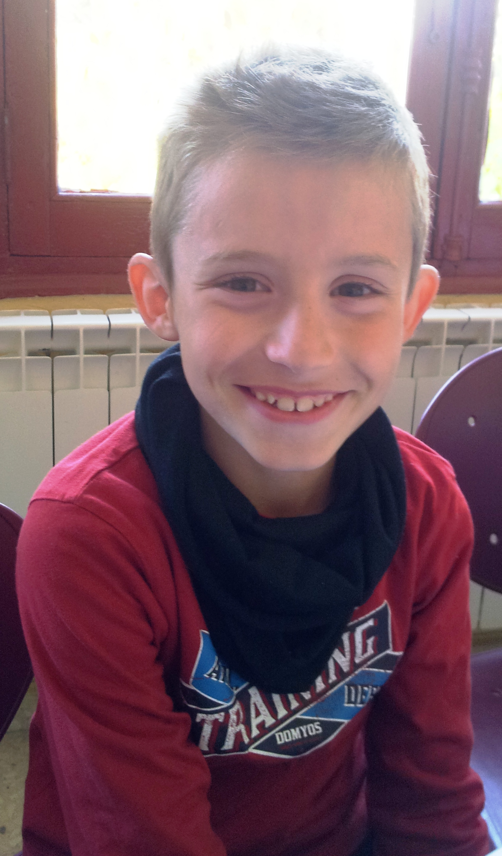
Hello!

My name is Álvaro.

I´m 8 years old.

I´m from Spain.

I live in Socuéllamos.

I go to school by car.
Today is Tuesday.
My school´s name is Gerardo Martínez.
There are twenty-two students in my classroom.
My English teacher is Carlos.
My best friend is Alex.

